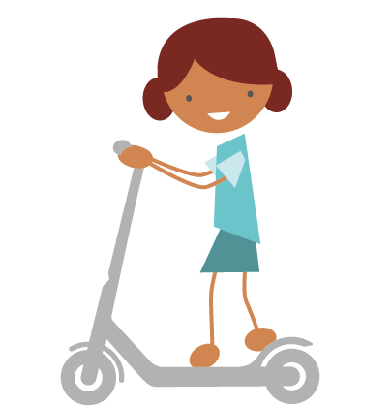
How do you travel to school?
This document is available in Welsh / Mae’r ddogfen hon ar gael yn Gymraeg

____________ School and Cardiff Council are currently looking at preparing an Active Travel Plan to encourage more walking, cycling and scooting to school amongst pupils, families and staff. As part of this process we would like to engage with families to understand the ways you travel to school and how we can support you.

1. How far do you live from the school? Can you map your route on the maps overleaf?

- Less than 1 mile
- Less than 2 miles

- Less than 3 miles
- Over 3 miles

2. How does your child usually travel to school?

- Walk
- Cycle
- Scoot / Skate
- Car
- Public transport
- Other. Please state: ____________

3. What do you feel are the barriers or concerns you have in your child travelling actively to school?

- I don’t have time.
- I need to drive somewhere else after dropping them.
- I live too far.
- There are not enough safe crossings.
- Other Please State:

- My child is not aware enough of safety on roads.
- My child does not have a bike or scooter.
- My child cannot ride a bike.
- The pavements are not safe.
- The weather isn’t good enough.

4. What changes do you think would enable you to travel more actively to school?

_______________________________________________________________________
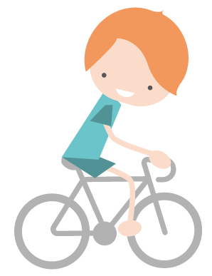
Thank you for taking the time to help us with this questionnaire.

What route do you use to get to school?
Can you map it out on one of the below maps.

