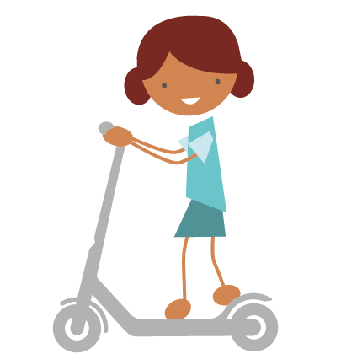
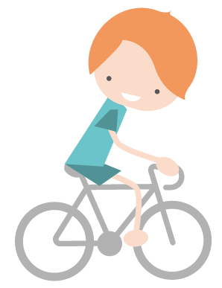

___________ School Active Travel Plan

Our Active Travel Pledge: EG: We pledge to work towards the actions on our plan to become an Active Travel School and increase families walking, cycling and scooting to school.

Action | Who is responsible? | When will it be completed? | What will success look like? | Next Step
See list of actions for ideas for your Travel Plan | EG: governor, headteacher, eco council | EG: end of summer term | EG:  Display changed termly,  Increase in use of bike stands | What could you do in the future to make even more progress?

  - Date:

