Carbon Footprint Quiz 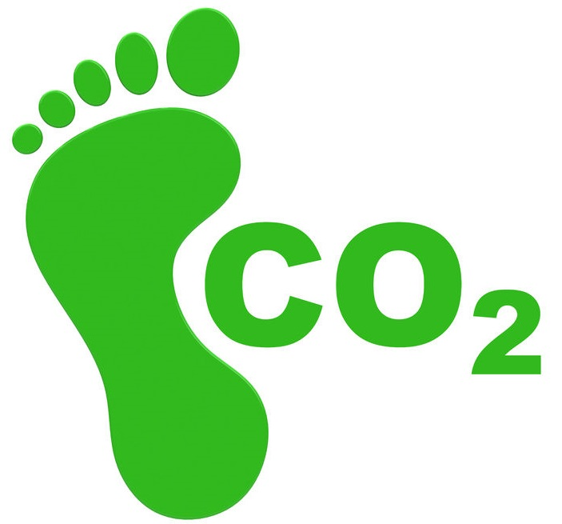

1) How do you usually get to school? |  | Points
A) Walk, cycle or scoot | B) Bus or train
C) Park and stride | D) Car

2) When with your family, how do you usually travel? |  | Points
A) Walk, cycle or scoot | B) Bus or train
C) Park and stride | D) Car

3) How often do you travel in an aeroplane? |  | Points
A) Never | B) Every few years
C) Every year | D) More than once a year

4) How do you describe your diet? |  | Points
A) Meat in most meals | B) Meat in some meals
C) Vegetarian | D) Vegan

5) How much of the food you have is thrown away? |  | Points
A) I don’t often finish my meals | 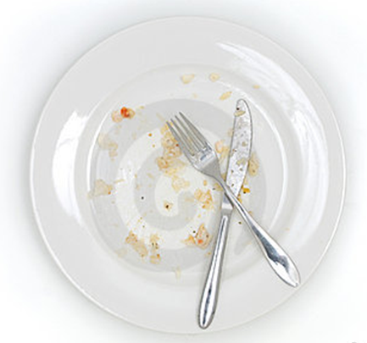  B) I sometimes finish my meals
C) I usually finish my meals | D) I always finish my meals

6) How often do you have plastic drink bottles? |  | Points
A) Every day | B) Every week
C) Rarely | 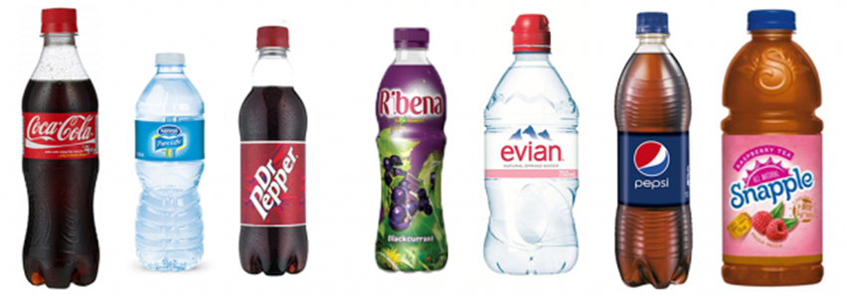  D) Never

7) Which type of home you live in? |  | Points
A) Detached | B) Semi detached
C) Terraced | D) Flat

8) Do you turn off lights and appliances instead of leaving them on standby? |  | Points
A) Always | B) Usually
C) Sometimes | D) Never

9) Do you have a pet? |  | Points
A) No pet | B) A cat
C) Another pet | D) A dog

10) Do you use reusable carrier bags? |  | Points
A) Always | B) Most of the time
C) Sometimes | 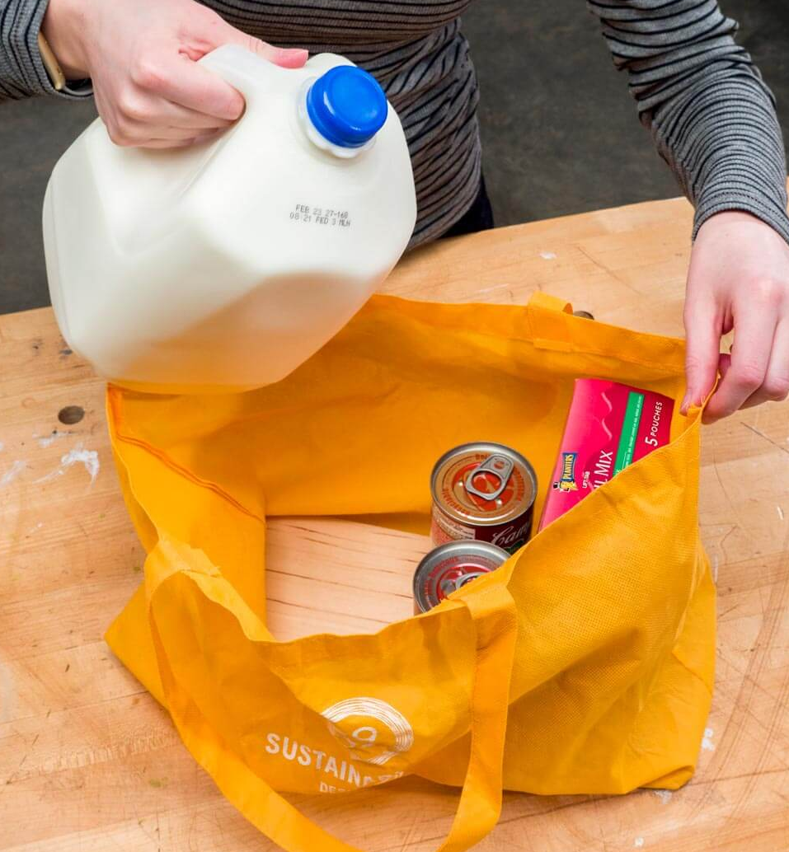  D) Rarely

11) How do you wash yourself? |  | Points
A) Always a bath | B) Usually a bath
C) Usually a shower | D) Always a shower

12) Do you turn off the water when you brush your teeth? |  | Points
A) Never | 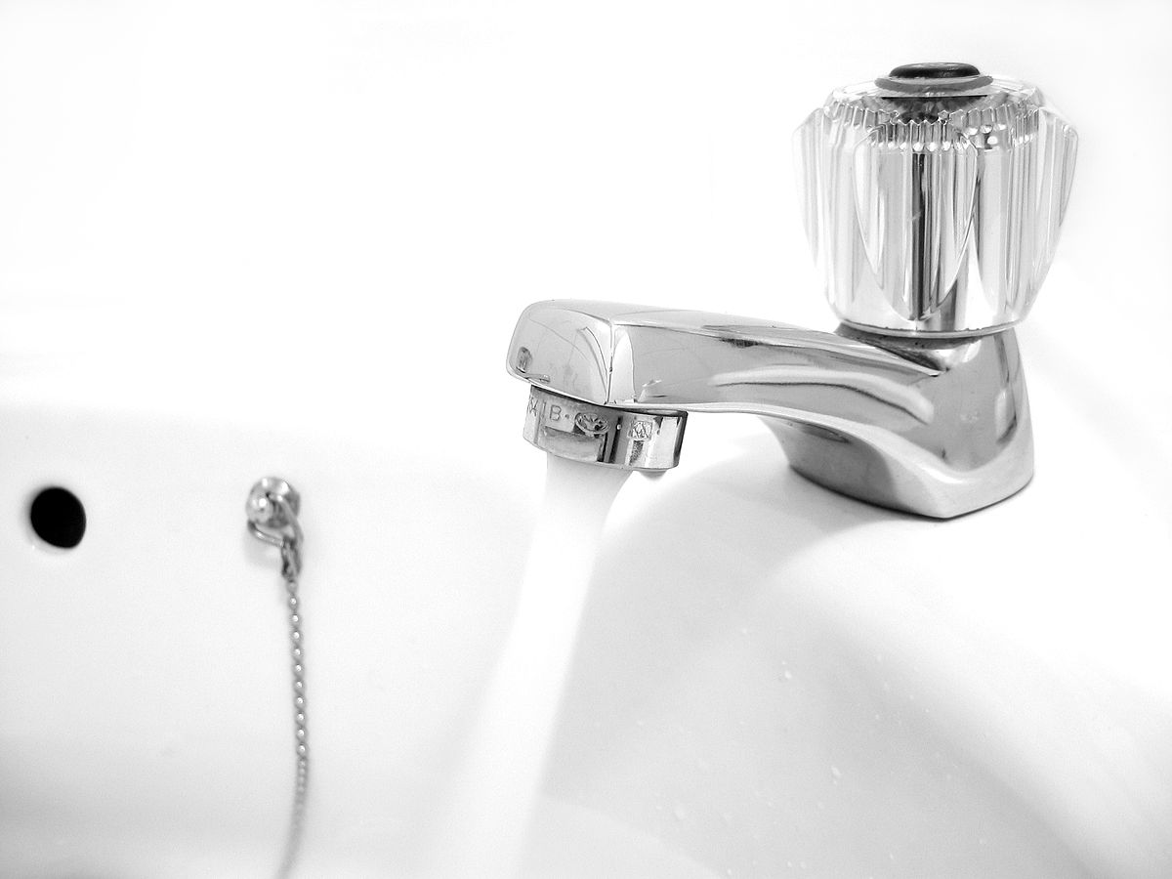  B) Sometimes
C) Most of the time | D) Always

13) How often do you get new clothes? |  | Points
A) I get most clothes from charity shops or given from friends and family | 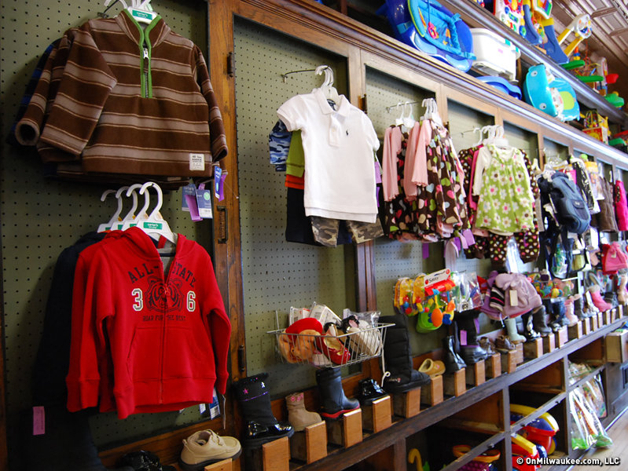  B) Every 6-12 months
C) Every 2-5 months | D) Every month

14) What do you recycle? |  | Points
A) I don’t recycle much | B) Some bottles and cans
C) Bottles, cans, glass and paper | D) I try not to buy things that can’t be recycled

15) How many hours a day do you and your family watch tv, use a computer or play video games? |  | Points
A) We don’t do them every day | B) 1-3 hours
C) 4-5 hours | D) 6 or more hours

Working out space:

My score is

Scoring Grid

Q | A | B | C | D
1 | 1 | 2 | 5 | 10
2 | 1 | 2 | 5 | 10
3 | 1 | 2 | 5 | 10
4 | 10 | 5 | 2 | 1
5 | 10 | 5 | 2 | 1
6 | 10 | 5 | 2 | 1
7 | 10 | 5 | 2 | 1
8 | 1 | 2 | 5 | 10
9 | 1 | 2 | 5 | 10
10 | 1 | 2 | 5 | 10
11 | 10 | 5 | 2 | 1
12 | 10 | 5 | 2 | 1
13 | 1 | 2 | 5 | 10
14 | 10 | 5 | 2 | 1
15 | 1 | 2 | 5 | 10

The results!

How many points do you have?

Less than 30 points: Eco star!  You clearly think carefully about the choices you make and how they impact the planet. Keep up the good work and try to show others the good work you are doing. | Between 30-60 points:  You’re nearly there!  You think about a lot of the choices you make which impact the planet. You are making some great choices. Look back at your quiz and make one change which will make a difference. Well done!
Between 60-80 points:  Could do better.  You think about some of the choices you make and how they impact the environment. You need to make some changes to make more of an impact. You are making some great choices. Look back at your quiz and make two changes which will make a difference. Try the quiz again in a month and see if your score has changed. You can do it! | Over 80 points:  You need to make some changes.  You need to make some changes to your lifestyle to make sure you are not having a negative effect on the environment. Look back at your quiz and make three changes which will make a difference. Try the quiz again in a month and see if your score has changed. You can do it!

