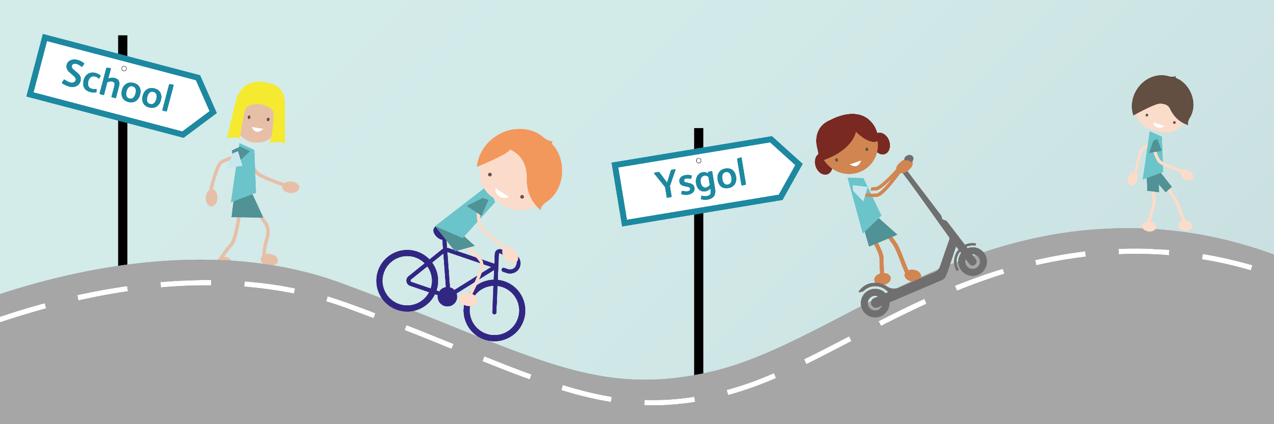

Active Travel Planning
This planning is a series of independent play based activities based around the topic of Active Travel. Each activity has an objective as well as the overarching Health and Wellbeing What Matters Statements for the whole unit. Despite the lessons being set out in a unit of 14, we encourage you to be as creative as you would like with these activities, they do not need to be followed closely, but are aimed to give you ideas of ways to teach and engage with active travel within a classroom setting. As well as these activities, we also have teacher led lessons available which you may like to use alongside these activities. We have given a teacher led learning lesson for every few play based activities.
Despite the activities being based around the Health and Wellbeing area of learning, the lessons are cross curricular and cover many of the other areas of learning. We would advise you to check the resources and powerpoints are applicable for the age group and abilities of your class. Some potential ways to differentiate are suggested, but these will need to be tailored for the specific needs of your pupils. ↑ indicates a more challenging task for the activity and ↓ is a way of simplifying the activity. Resources and powerpoints available are highlighted in bold.
If you have any further questions or would like support in delivering these lessons, please do contact us via travelplans@cardiff.gov.uk

Health and Wellbeing What matters Statements | - Developing physical health and well-being has lifelong benefits.  - How we process and respond to our experiences affects our mental health and emotional well-being.  - Our decision-making impacts on the quality of our lives and the lives of others.  - How we engage with different social influences shapes who we are and our health and well-being.  - Healthy relationships are fundamental to our sense of belonging and well-being.

Activity | Lesson Objective | Independent Play Based Learning | Resources required
1 | To understand what travel is. | Children use a variety of 3D shapes or blocks to create a city or village scene in groups or pairs. Children use lollipop sticks to create puppets of people travelling in different ways to tell travelling stories in the scene.  ↓Images of ways to travel in centre of table to give travel ideas: train, bus, car, bike, scooter, walking | · Variety of construction materials such as lego, wooden blocks, duplo or junk modelling materials  · Lollipop sticks, white card, colouring pencils and sellotape for puppets.
2 | To understand everyone travels every day to school / nursery. | Children make a personal book of their ‘walk to school’. On each page, draw the things they walk past. If they drive, the things they drive past. Start with their home on page 1, at the end, arriving in school.  If time allows, ask families to take photos on their route to school.  ↓Use photos of local area to support  ↑ Children add words, labels, or sentences to each page, or write information book to explain their route. | · Variety of paper  · Paper fasteners and hole punchers  · Images of local area
3 | To understand people travel in different ways. | Children have clipboards to ask their classmates how they travelled to school. Children use Resource 1 to create tally chart or tick to show how they travelled. This activity could also be completed outside.  Another day or time, repeat the activity with children asking their classmates how they would like to travel to school with Resource 1 (page 2) . Discuss the differences.  Differentiation:  ↓ to tick for each friend with images on chart to support.  ↑ to create clear tally chart and use Resource 2 to make simple bar chart to show results. | · Clipboards  · Print out of Resource 1  · Pencils  · ↑ Print out of Resource 2
4  Adult led learning | To understand people travel in different ways.  To understand what active travel is. | As a class or group, create a human pictogram with children lining up to show how they travel to school.  After finding out how they would like to travel to school, recap the human pictogram and discuss with class what the difference was between the first and second human pictogram.  Introduce the topic of ‘active travel’ and what it means using PPT 1. Explain to children that active travel is a way to travel or move to different places which keeps your body moving like cycling, scooting or walking. Show images of travel and discuss which are active and which are not. How many of your class travelled actively? | 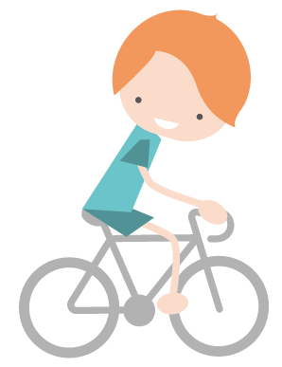  · PPT 1
5 | To understand what active travel is. | Children use Resource 3 to sort travel into either ‘active’ or not active travel by cutting and sticking.  Differentiation:  ↓ to work in a group with Resource 3 printed onto a3 paper.  ↑ Discuss how catching the bus or train can be active if the bus stop is far away from where you are going. Discuss getting off the bus or train a stop earlier.  ↑Write label for each image. | · Print out of Resource 3  · Scissors  · Gluesticks

Activity | Lesson Objective | Independent Play Activity | Resources required
6  Adult led learning | To understand why active travel is important. | Use PPT 2 to discuss why active travel is important such as physical and mental health, cost, less cars means less accidents, time to chat to friends and family, improves concentration and better for the environment.  As a class sort who active travel helps: Individual people, families, communities and the world | • PPT 2
7 | To understand how active travel affects my physical and mental. | In outdoor area, set up circuits with stations to keep children exercising, using chalk on the floor to show the direction between stations and the number they need to do. Some examples:  • Star jumps  • Running on the spot  • Running zig zag between cones  • Bouncing basketballs  • Hopscotch  • Skipping  Children then work with a partner to draw around themselves on the floor with chalk, they add in arrows, pictures and /or labels to show what has happened to their body after exercise. Adult show that this also happens when you walk, cycle or scoot to school, but doesn’t happen when you travel in a car. Discuss how physical activity helps your mental health. | • Variety of sports equipment  • Chalk
8 | To understand how people travel affects the world. | Create a mini polar region small world in large tray with ice frozen overnight. Use miniature polar animals, glass beads, fake snow. Throughout the day discuss what is happening to the ice….Explain that because lots of people use cars too much (as well as other things), the ice is melting changing the habitat.  Use a globe to show where these areas are.  ↑ Discuss other things which affect global warming.  ↓ Resource 4: Images of polar regions to display and support | • Tuff spot tray  • Polar animals  • Ice  • Fake snow  • ↓Resource 4: Images of polar regions to display and support
9 | To understand how people travel affects the world. | Children cut and stick images of things they do which are good and bad for the world around us / environment using Resource 5  Discuss at circle time one change they can make which can help the environment/planet. Walking to school is a good one!  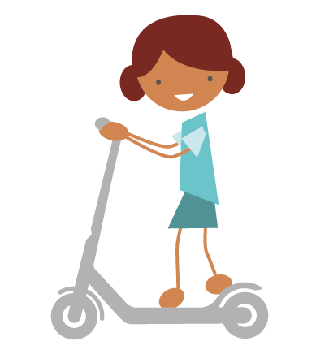  ↑ Write a pledge to make one positive change for the environment.  ↓Have fewer options to sort | • Variety of paper  • Paper fasteners and hole punchers  • Images of local area  • Print out of Resource 5

Activity | Lesson Objective | Independent Play Based Learning | Resources required
10  Adult led learning | To understand the reasons you don’t travel actively can be changed. | Question children why they sometimes may travel by car or bus instead of travelling actively. Ask children to chat with a partner. why they don’t always travel actively, such as distance, time, weather and safety. Make a class list of what those reasons are on a whiteboard. Use PPT 3 with images to support.  Explain that sometimes these problems can have a solution, and discuss what they could be. | • Whiteboard and pen  • PPT 3
11 | To understand how to keep myself safe in different weather. | Ask children to look outside at the weather and discuss the different types of weather.  Children then draw an outfit for themselves to wear during wet weather using Resource 6. Will it keep you dry? Is it comfortable?  ↑ Add labels and research different types of wet weather clothing online.  ↓ Resource 7: images of bad weather and clothing to support  Has it got a hood? Check the small print...Is it waterproof or resistant? What shoes should you wear? Are there any accessories you can add? Eg..Umbrella. Ensure children are realistic...How much does it cost? Would you wear it? Is it comfortable? Will it definitely keep you dry? | - Resource 6  - Resource 7: images of bad weather and clothing to support
12 | To understand that travelling by car can sometimes take as long as travelling actively. | Children play Game in pairs. [Resource 8]  Before you start the game, decide who will be a walker and who will be in a car by turning over the allocation cards at random. Lay out the ‘walker cards’ face down in front of the walker player, ‘driver cards’ face down in front of the driver player. Give each player 10 ‘minute counters’ and leave some in the middle. Players take turns to turn over one of their ’driver cards’ or ’walker cards’ and either take minutes away from their ten or add more. Whoever has less minutes after turning 5 cards is the winner. What have you found out during the game? Explain that for shorter distances, walking can often be quicker.  ↑Discuss how using a bike or scooter could also affect the time.  ↓ Adult support with reading cards as required. | - Resource 8 printed out:  -16 driver cards printed per pair  -16 walker cards printed per pair  -Minute counters  -Driver and walker allocation cards
13  Adult led learning | To understand how to keep myself safe while travelling actively. | Recap on the reasons why you wouldn't travel actively to school from previous lesson, such as safety. Explain that today you will look into why safety should not stop you from being active while travelling if you know how to be safe.  Show children the video: www.think.gov.uk/resource/crossing-roads. Ask children to practice saying: Stop, Look, Listen and Think as a class.  Children set up a mini road outside using chalk, drawing a crossing, pavements and road markings in a group. Use scooters, bikes, toy cars, dressing up clothes to support. If possible, take groups of children on a walk around the local area, practising crossing roads using the phrase: Stop, Look, Listen and Think.  ↑ Use Resource 9 images to try crossing and being safe at different obstacles. This can also be used when on walk around the local area.  ↓ To continue repeating : Stop, Look, Listen and Think | · Chalk  · Variety of dressing up clothes  · Toy cars, scooters, bikes  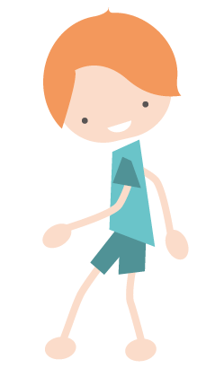  · ↑Resource 9

Activity | Lesson Objective | Independent Play Based Learning | Resources required
14 | To be able to plan a safe route. | In the centre of a table, tape a large map of local area. Children find their home, and school, and work together to draw the route they take to school using a different colour pen for each child. Children use Resource 10 to show what they come across on their route, and any obstacles that they will need to be careful when walking, eg: crossings.  ↑ Ask children to look and plan for alternative and safer routes . Children use Resource 10 to plan their improved route. Use online map to support. https://www.cardiff.gov.uk/ENG/resident/Parking-roads-and-travel/Walking-and-cycling/Documents/Cardiff 2018_WEB.pdf  ↓ Images of local area to support | • Large printed map of local area  • Variety of colouring pens/pencils  • Print out of Resource 10

Ideas for further work in other AOLE’s:
Expressive Arts | Humanities | Languages, Literacy and Communication | Maths and Numeracy | Science and Technology
- Use a variety of instruments to make rhythms, beats and sound effects of different modes of transport.  - Children use a variety of media such as charcoal, pastels, sketching pencils to make sketches and artwork of a variety of transport  - Children make junk models of transport modes | - Children label images of transport from the past. Discuss how people travelled differently, did they travel as far? Why? Were they healthier?  - What is the difference in active travel rates in different countries? Research Denmark online and discuss the differences.  - Create a simple map of the area outside school, adding labels to show things which help people travelling actively: eg-pavements, crossings | - Children create a roleplay based around their journey to school. Make into a playscript or story.  - Write a letter to local MP/Councillor stating the problems your school has regarding traffic congestion.  - Read the story ‘on the way home’ by Jill Murphy, discussing the girls route and how she travels. | - Children use 2D shapes to make images of modes of transport: eg, circles for wheels. Cutting and sticking shapes could also be used.  - Children use stopwatches to time themselves walking, running, cycling and scooting from one point to another. Make notes on clipboards.  - Children tally transport passing the school, which is the most popular? Least? What would happen if more people cycled?  - Children make an exercise chart to show how much they exercise each week. How does active travel make a difference? | - Ask children to observe animals on their route to school, such as ladybirds, spiders etc. Children create paintings of the creatures they have seen. What would happen if there were fewer roads?  - Children create maps of their route, to take a beebot from home to school.  - Children create a presentation to persuade peers in assembly to travel actively.

