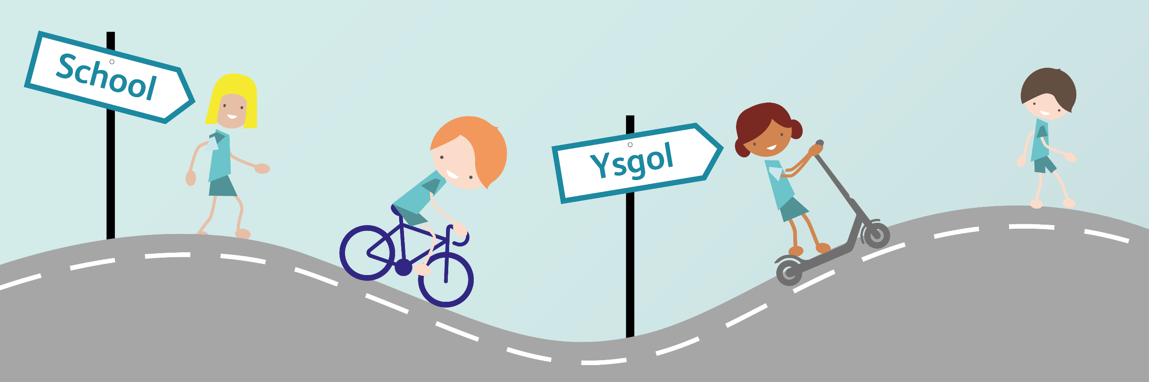

Active Travel Planning
This planning is a series of 12 teacher led lessons based around the topic of Active Travel. Each lesson has an objective as well as the overarching Health and Wellbeing What Matters Statements. Despite the lessons being set out in a unit of 12 lessons, we encourage you to be as creative as you would like with these lessons, they do not need to be followed closely, but are aimed to give you ideas of ways to teach active travel. As well as these lessons, we also have play based lessons for child led learning available.

Despite the lessons being based around the Health and Wellbeing area of learning, the lessons are cross curricular and cover many of the other areas of learning. We have given a few further ideas underneath each couple of lessons. We would advise you to check the resources and powerpoints are applicable for the age group and abilities of your class. Some potential ways to differentiate are suggested, but these will need to be tailored for the specific needs of your pupils. ↑ indicates a more challenging task for the activity and ↓ is a way of simplifying the activity. Powerpoints have been created for each lesson, as well as resources. These are highlighted in bold.
If you have any further questions or would like support in delivering these lessons, please do contact us via travelplans@cardiff.gov.uk

Health and Wellbeing What matters Statements | - Our decision-making impacts on the quality of our lives and the lives of others.  - Developing physical health and well-being has lifelong benefits.  - How we process and respond to our experiences affects our mental health and emotional well-being.  - How we engage with different social influences shapes who we are and our health and well-being.  - Healthy relationships are fundamental to our sense of belonging and well-being.  - Healthy relationships are fundamental to our sense of belonging and well-being.

Lesson | Lesson Objective | Whole Class Introduction | Individual/group work | Differentiation | Plenary | Resources
1 | To understand what Active Travel is. | Ask children open ended question: What is Active Travel? What do you think it could be?  Is getting a bus active travel?  Use PPT to show variety of transports and discuss if they are active or not. Discuss how walking to a bus or train, and parking and striding / cycling are also active travel.[PPT 1] | Children use a clipboard in pairs to find out how their class travelled to school. Create a tally chart to work out how the class travelled. [Resource 1]  After finding the results from the class, create a ↓ chart or pictogram What does the ↓ chart show us?  Children then repeat tally activity asking which way children would like to travel to school. What is the difference in percentages? ↓ chart of how children would like to travel to school.  If preferred, split the class, half making charts on ways children travelled to school, half making charts on how they would like to get to school. | ↑ to work out percentages and create Pie chart.  ↓ to use chart already set up to support [Resource 2] | Have a discussion as to what would enable us to change the way which we travel to school? What could we do to enable that change? | PPT 1  Resource 1  Resource 2 for ↓
2 | To understand the benefits of active travel. | Ask children open ended question: Why is active travel important? What are the benefits? Create a mindmap of the benefits children can think of.  Develop understanding of benefits using PPT.  How do you feel when you walk? Cycle? Scoot? Chat to your family?  [PPT 2] | Children work independently or in pairs to cut and stick benefits into table. [see Resource 3]. Discuss how and where they overlap? | ↓ have less benefits to sort.  ↑ also rank benefits as to which they think is most important. | Discuss how travelling to school actively will also affect how we travel as adults and could have lifelong benefits. | PPT 2  Resource 3 (ideally printed to a3)  Scissors and Glue  Tablets/laptops per pair
Ideas for further work in other AOLE’s:
Expressive Arts: Create sound effects using a variety of instruments for each form of travel in groups.
Humanities: Using a map, locate where each child in the class lives, measuring who lives closest and furthest from school. Does distance affect how we travel?
Maths and Numeracy and Languages, Literacy and Communication: : Children do tally chart at the end of the day to record how children travel home, by asking questions and recording on clipboards.
Science and Technology and Languages, Literacy and Communication: Children then create a PPT in pairs to show in assembly the importance of active travel to their school community.

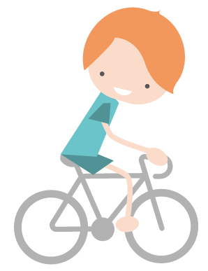

Lesson | Lesson Objective | Whole Class Introduction | Individual/group work | Differentiation | Plenary | Resources
3 | To understand how active travel affects our physical and mental health. | Recap on the benefits of Active Travel. Why is Active Travel important? Can you remember?  Explain that this lesson will be focussing on the physical and mental benefit of Active Travel.  Question children, What exercise do you do each week?  In pairs use whiteboards to add up the minutes spent exercising. Then introduce how much exercise children should be doing: 60 minutes. Are they doing enough? How would travelling actively change this? [PPT 3] | Children create a weekly plan for themselves and total how many minutes exercise they get each week. Discuss how it is not a competition, and each childs will be different. Children show partner the exercise they do. How many minutes in total? [Resource 4]  Children then look at how they can make small changes to improve the minutes of exercise they get. Children make a plan for the following week. Discuss how it needs to be realistic, for example, if they are travelling to school in a car every day. Could they begin by walking once a week? Aim to just increase minutes of exercise per week.  [see Resource 5] | ↑ to discuss limitations to plan. What will stop them from doing this? How can they overcome the problems? EG: parents drop them off in car and then drive to work, could they do a park and stride? | Children take plan home and discuss it with their families to see if it is realistic for their family. Change the plan if necessary, and try to include family members. Try to complete the plan for that week.  ↑ to explain limitations and how to overcome them.  Discuss how keeping up their new plan can help as they grow older. | PPT 3  Resource 4 or own weekly planner  Resource 5
4 | To understand how active travel affects our community. | Ask children how their exercise plan went. How did it make them feel? Did it affect their mental health.  Recap on benefits of active travel.  Introduce that we are going to look at how active travel benefits our community.  Ask children to close their eyes and imagine they are walking to school. What do they walk past? Who do they speak to? Who do they walk with? (Discuss family, neighbours, shops, landmarks, parks).  Then in partners, children tell their friend their journey and what they see and speak to along their way. Make notes on whiteboards.  Explain that walking reduces social isolation, improves our own relationships, increases spending in local shops and also eases traffic congestion in the community. [PPT 4] | Children do a line journey of their route to school. Include parks, neighbours, shops, roundabouts, crossings, bus stops, cafes, bridges, special buildings, etc.  [Resource 6]  Ask children to show their partners their route. Explain how the conversations you have make an impact on yourself and others, and the money you spend makes an impact on small business. | ↑ children to colour code their journey, adding in people they speak to, and where they may spend some money. | Discuss how active travel has an affect on our government and wider community.  If we all walked more we could save the NHS as much as £17 billion over the next 20 years. Why? | PPT 4  Resource 6
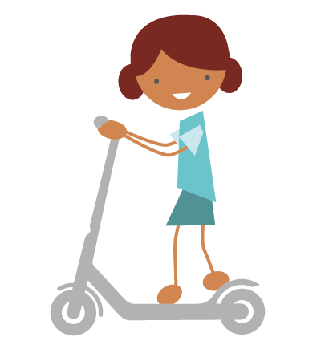
Ideas for further work in other AOLE’s:
Expressive Arts: Children create a sketch of the favourite part of their route, including places they go past, such as parks, shops. Use a variety of media: charcoal, chalk. Children can just focus on one part
Humanities: Use historical maps to create a journey line of how their route would have differed in the past. Question older members of the community, including parents and grandparents. Has the community changed for the better or worse?
Maths and Numeracy: Children work at home to create a plan for their family. Children work out how many minutes of exercise they do of exercise per week, and then after their plan.
Science and Technology and Languages, Literacy and Communication: Children use a digital camera to take photos of the route they take to school, and create a presentation to show
their route to their class.

Lesson | Lesson Objective | Whole Class Introduction | Individual/group work | Differentiation | Plenary | Resources
5 | To understand how active travel affects the environment. | Introduce the topic of climate change: (watch videos first to check appropriateness for class)  https://www.youtube.com/watch?v=CMOEcUPGi9c  Or  https://www.youtube.com/watch?v=0Puv0Pss33M  Ask children to think what is the missing gap from the facts on [PPT 5].Ask children to raise their hands to vote, revealing the answer on the next slide.  Explain to class what a carbon footprint is: Total carbon emissions caused by a person. [PPT 5] | In pairs with [Resource 7} or using PPT 5b, work through quiz to give each pupil a Carbon Footprint Score, making notes on whiteboards. Then plot onto .  In a group or class, work out who has the smaller carbon footprint and who the highest. Children then look back at their scores and see what changes they could make to improve their score. Chose one or two changes and write a pledge for themselves to take home. [Resource 8]. | ↑ WWF quiz: https://footprint.wwf.org.uk/#/ | Introduce how road transport affects air pollution. Explain to children that being in a car offers no protection from air pollution. Would you have thought this? | PPT 5  Resource 8  Resource 7 or PPT 5b  Whiteboards and pens
6 | To understand the negative aspects of active travel can often have a solution.  (Time) | Recap on the tally charts done in lesson 1. Ask children to chat to a partner about why they would chose not to travel actively. What would stop them? Create a mindmap as a class of the reasons people don’t travel actively.  Introduce the idea of rushing to get to school by asking children what phrases they regularly hear from their parents while getting ready for school.  Tell children that the average walking speed is 3 miles an hour. Ask children to make notes on what slows down the journey to school in a car. Children work in pairs to make a list on whiteboards/paper. [Resource 9 if wanted]  [PPT 6]. | Children play Active Travel Game in groups with counters and dice. One child is the walker...who does not activate any problem cards. Children roll dice and work their way through the game. If they land on a time card, turn card and take the necessary action. [Resource 10]  What have you found out during the game? | ↑ children design their own game and /or problems which slow down a car journey. | Cars can sometimes be faster than walking, but not as fast as you first may think. Does speed outweigh the other benefits if the speed is not as great as you first thought? What would happen if you were cycling or scooting? Recap on the benefits. | PPT 6  Resource 9 (if wanted)  Resource 10  Dice
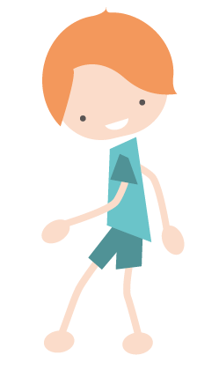
Ideas for further work in other AOLE’s:
Expressive Arts: Create icy landscape painting or collages to show the effect of climate change on the polar regions. Younger children can create puppets with speech bubbles for
polar animals.
Maths and Numeracy: Children work out the time taken by the things which slow down a car journey. How much faster would the journey be?
Languages, Literacy and Communication: Children write a newspaper article persuading members of the public to travel actively to help the environment.
Science and Technology and Humanities: Research the effect of climate change on the planet. Note the differences that have happened. Who and what has been most effected?
Discuss and debate what the future will look like.

Lesson | Lesson Objective | Whole Class Introduction | Individual/group work | Differentiation | Plenary | Resources
7 | To understand the negatives aspects of active travel can often have a solution.  (Weather) | Recap on the reasons why you wouldn't travel actively to school from previous lesson. Question children why they wouldn't cycle or walk to school?  Explain that today you will look into why weather should not stop you from being active while travelling.  Discuss the quote from Ranulph Fiennes “There is no such thing as bad weather, only inappropriate clothing”. What does this mean in an active travel context? Discuss how weather affects clothing choices. [PPT 7] | Children chose a more extreme weather such as rainy, snowy, icy or very sunny to design an outfit for. Research clothes for their chosen weather using tablets/computers in pairs. Some examples of websites: Mountain Warehouse, JD Sports, H and M, Nike, Sports Direct, Marks and Spencer, Northface, Primark, Berghaus, etc.  Children then draw an outfit for themselves using the items they have researched. Add labels. [If wanted-Resource 9 can be used]  Has it got a hood? Check the small print...Is it waterproof or resistant? What shoes should you wear? Are there any accessories you can add? Eg..Umbrella. Ensure children are realistic...How much does it cost? Would you wear it? Is it comfortable? Will it definitely keep you dry? | ↑ children to add up cost of outfit. How can they make it cheaper?  ↓ pupils to design their own without using websites...adding basic clothing such as waterproof jacket, umbrella, wellies. | Discuss with children how to ensure you are safe while travelling during extreme weather. Possibility of high visibility clothing while cycling. Should you cycle during icy conditions? | PPT 7  Resource 11  Tablets/laptops per pair  Pencils and  colouring pencils
8 | To understand the negatives aspects of active travel can often have a solution.  (Safety) | Recap on the reasons why you wouldn't travel actively to school from previous lesson.  Explain that today you will look into why safety should not stop you from being active while travelling if you know how to be safe.  Explain to class that they are going to learn how to approach a variety of obstacles they would come across day to day whilst walking. What do they normally do? What mistakes have they seen other people make? How would they advise a younger sibling to approach it?  Use [PPT 8] to show hazards and discuss as a class. | Play game in pairs to introduce hazards whilst walking. : https://www.think.gov.uk/Resource/take-the-lead-game/  In mixed ability groups or pairs, use photos of a variety of different obstacles whilst walking, (chose obstacles most relevant to local area) 1 photo for each group. [Resource 12] How would you approach them, ensuring safety? Mindmap the obstacle as a group.  Groups then compile a role play: one way of using the obstacle unsafely, and another safely. Children can write scripts for the role-play and/or create videos using cameras to present their work. Use ipads to research best way to approach.  If wanted, a playground or hall could be used to create the obstacle, such as using chalk outside or masking tape in a hall to create a zebra crossing. | ↑ Question children around how distractions could change these obstacles.  ↓ support those who would struggle to assess risks independently. | Children either show their videos to the class, or do their role plays.  Discuss what made the obstacle safe.  Finally look at the think website, and look at the roads around your school as a class. Where have the accidents occurred? Why?  https://www.think.gov.uk/thinkmap/ | PPT 8  Resource 12  large paper and pens  Tablets/laptops per pair
Ideas for further work in other AOLE’s:
Expressive Arts: Design an outfit using collage materials.
Maths and Numeracy: Children to work out costings of outfit? Which design is cheapest? Does paying more make the outfit more suitable for the weather?
Languages, Literacy and Communication: Children write script for their role plays and then show younger children in the school their plays showing them how to stay safe while walking.
Science and Technology and Humanities: Research how people around the world dress appropriately for the extreme weather where they live: mountainous regions, rainforests,
deserts or polar regions.

Lesson | Lesson Objective | Whole Class Introduction | Individual/ group work | Differentiation | Plenary | Resources
9 | To understand that distractions can affect my safety when travelling actively. | What distractions can affect you when you are walking? Create a list as a class (EG: chatting to friends, shops, mobile phones, weather, tiredness, mental health). How will this affect your awareness? Use images on PPT 9 to prompt ideas.  Watch video of people using their phone whilst walking. What would happen is this were on a road?  https://www.youtube.com/watch?v=swaW8J2Nx1E&t=16s  Children watch 2 videos of ‘Tales of the road’. In pairs, discuss what distractions were in the video and how they created the accidents.  https://www.youtube.com/watch?v=UxHBVgM9zfg  https://www.youtube.com/watch?v=67XsZ8lwORk  [PPT 9] | Teacher demonstrate to class how to use Think map shown in previous lesson.  https://www.think.gov.uk/thinkmap/  Children use Think map on ipads or laptops in pairs to see accidents close to their home, and local area. Discuss with partners why the accidents could be in those particular locations.  Reassure pupils that just because there may have been an accident in the past, it doesn’t necessarily mean that their area is unsafe – but that it’s important to be more aware of the potential risks and how to deal with them.  Children create a short story of walking to school (Use childrens own journey line from lesson 4 to support) where they have distractions within their journey. Children can chose if they arrive safely or not to school.  Children have distraction cards (Resource 13) to give ideas to add to their story. Will any of the distractions cause an accident? | Staff to support with locating places on a map and literacy skills in searching  ↑ children to be given distractions cards at random and need to include them in their story.  ↓ children to have only one distraction. | Children read aloud their stories to class mates.  Is it only pedestrians which are distracted? How can drivers be distracted?  (glare, mobile phone, weather, passengers, illness, eyesight, tiredness.) Emphasise that they have to assume that every driver has not seen them and is distracted. | PPT 9  Resource 13  Tablets/laptops per pair
10 | To understand how to plan a safe, active journey. | As a whole class, recap on how to be safe as a pedestrian by playing the game:  https://roadsafety.scot/learning-zone/second/safe-behaviour/  Ask children to discuss what they found using the THIINK map in the previous lesson.  Where do you see maps? What do people use them for?  Demonstrate how to use a map to find where your school is and where you live. Show how the KEY works, how you can zoom in and out, how you can move to different areas. How do you locate where your school is? (Use google maps on ipads to support if necessary)  https://www.cardiff.gov.uk/ENG/resident/Parking-roads-and-travel/Walking-and-cycling/Pages/Walking-and-cycling.aspx  [PPT 10] | Give children either paper maps of their home area, or use https://www.cardiff.gov.uk/ENG/resident/Parking-roads-and-travel/Walking-and-cycling/Pages/Walking-and-cycling.aspx  Explain to children they have 2 tasks with their map – find their school, find the street where they live.  Using Cardiff Walking and Cycling Map, find the route they walk. If using a bus or public transport, route before bus stop and after. Are there any easier routes? (Google maps can be used if preferable)  If wanted, children can be given Resource 6 to create a new line journey of a better route to school, including obstacles which they need to ensure they are safe at and any new walking routes they have found. | ↑ children to plan a safe route for cycling to school from their home. Are there any cycle routes?  ↓ children to find their house and school on a map. | Question children, have they found a safer or quicker route? Ask these children to show their new route to the class.  Set children the task of trying their new route the next day. | PPT 10  Tablets/laptops per pair  Resource 6 (if wanted)
Ideas for further work in other AOLE’s:
Languages, Literacy and Communication: Children write a persuasive letter to their parents to be able to allow them to either walk or cycle to school if they do not already do so.
Expressive Arts: Children create a role play of the story they have written.
Maths and Numeracy: Measure distances travelled by using the scale on the map. This could be estimated or actual.
Science and Technology and Humanities Use google earth to find more suitable walking and cycling routes.

Lesson | Lesson Objective | Whole Class Introduction | Individual/ group work | Differentiation | Plenary | Resources
11 | To be able to design an active street. | Did anyone try the new route? What went well? What didn't?  Would a differently designed street help you or persuade you to travel more?  Show some images of streets that are not ideal for active travel. In pairs, or as a class, discuss the problems. Why would you not want to walk on those streets? Discuss atmosphere, safety and ease of walking and cycling.  Show children the 5 criteria and example pictures of what makes an ‘Active Street’. Discuss why they are important in supporting Active Travel.  Show a few examples of street designs. Discuss what the designs show.  Make a ‘Key’.  [PPT 11] | Using the following 5 criteria, make a Key around what will go on your own street outside school if it were to be made into an ‘Active Street’. Make sure there is at least one of each criteria in your key.  1: Easy to cross.  2: Places to stop and rest.  3: Make active travel easier.  4: Things to see and do  5: Greenery and planting.  Children work individually or in pairs to create an individual Key for their street design, using the 5 criteria to support them. | ↑ children to make costings around their Key, and have a budget to stick to.  ↓ children to use Resource 14 to support. | Children work in a group to share their keys, have they got at least one from each criteria? | PPT 11  Resource 14  Colouring pencils
12 | To be able to design an active street. | Children share the ‘Keys’ they have made.  Show children images of the street in Grangetown. Discuss the before and after pictures. What changes  were made? How has it improved?  Teacher model, drawing a simple map of the street outside the school. Then demonstrate how to add things from keys created yesterday to their design.  [PPT 12] | Children work individually or in pairs to first create a simple line map of the street outside their school. Include junctions on the road and entrances to school. Children then use their key created yesterday to add their design ideas to their map.  Discuss how you can begin to make these changes to the street outside your school. Discuss sending your plans to your local councillor. Research who the local councillor is and email them with ideas and plans. | ↑ to attempt creating the map to scale, working as group outside to measure distances.  ↓ to use pre drawn outline or create as a group | Discuss what children have learnt during these lessons regarding active travel. What changes will each child and family make individually and what changes can the school make? | PPT 12
Ideas for further work in other AOLE’s:
Expressive Arts: After designing the street, create a model of the street design as a group, using recycled materials, such as green tissue paper for trees, boxes for houses and school etc.
Humanities: Research countries and places in the world where children are more likely to travel actively to school. Discuss why they travel more actively: financial, geographical, street design etc. Create case studies of different locations.
Maths and Numeracy: Teacher hold n auction for children to ‘bid’ for things to add to their street. Each child has the same amount of money to start. They need to include something from
all 5 categories and then include them in their plan.
Languages, Literacy and Communication: Create a team within the school to try and engage families in coming to school actively. Meet throughout the year to put their plan together. Ask local
councillor to meet with group and discuss how they can create an environment where more families travel actively to school.
Science and Technology: Use a camera to take images of the street outside to then digitally apply the design.

