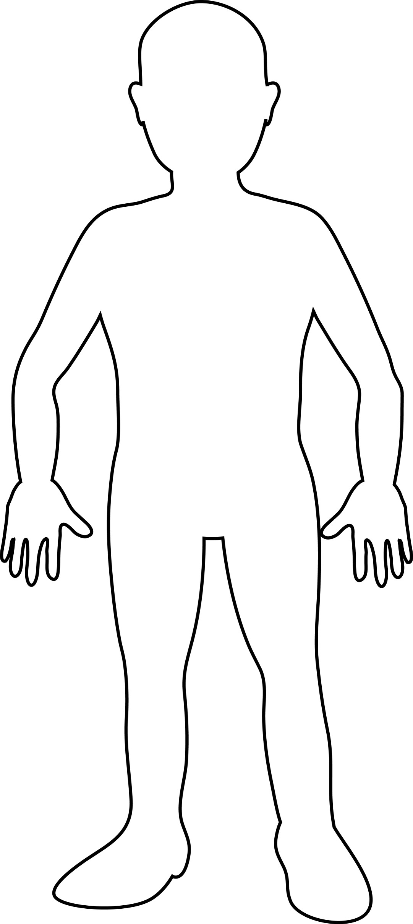My _______ Weather Active Travel Design

