Day | What exercise do I do? | 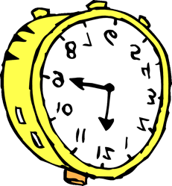Minutes | Do I get 60 minutes?
Monday
Tuesday
Wednesday
Thursday
Friday
Saturday
Sunday

How much exercise do I do?

Total minutes of exercise

